Vinita Ravivarma

Professor Ming

CS-340-16420-M01

October 20th, 2024

7-2 Project Two

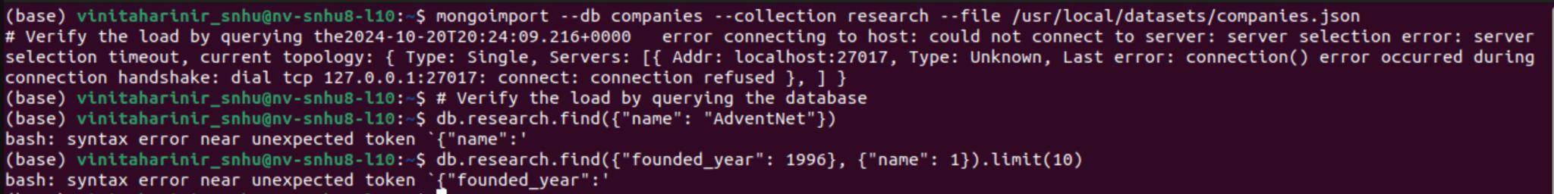

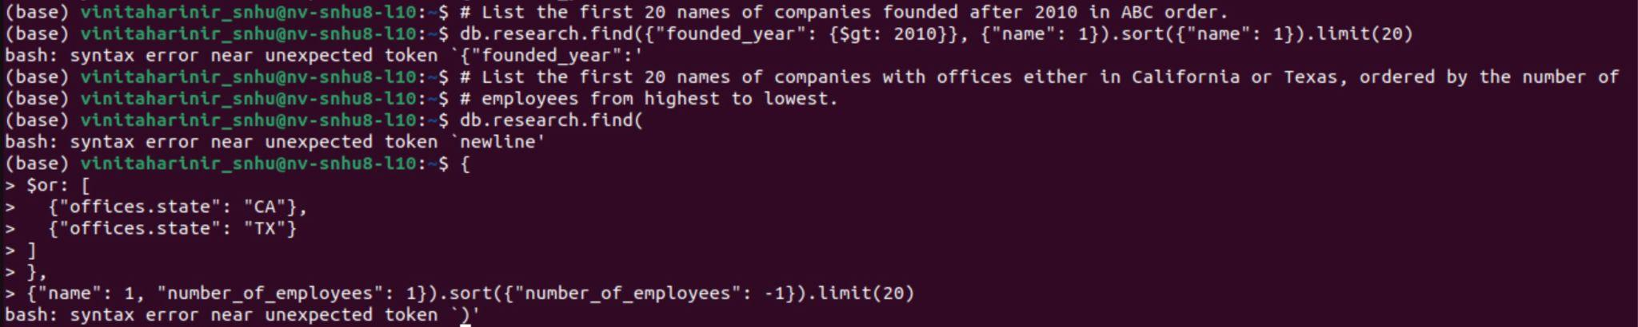

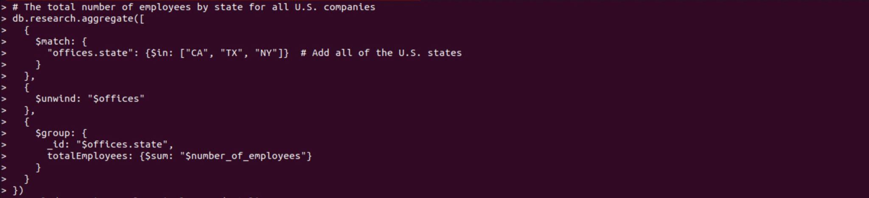



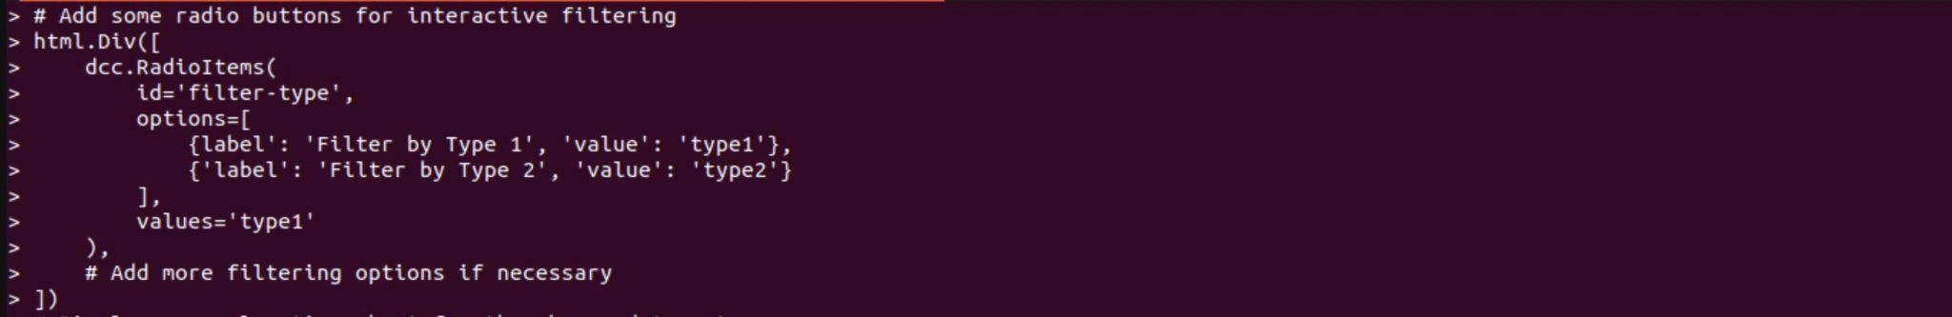

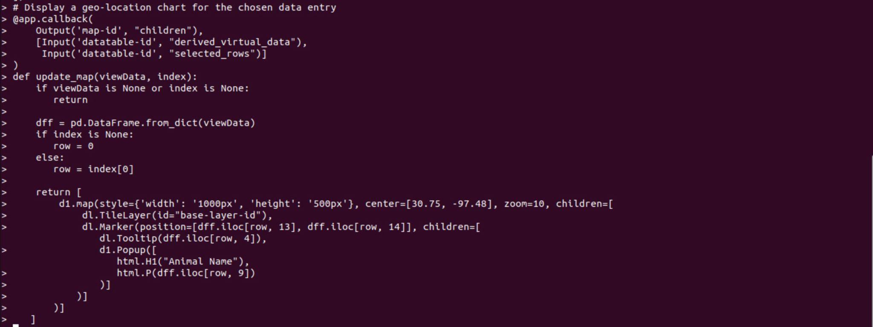

Explanation:

From these screenshots, a given solution establishes a Dash application linked to MongoDB throughout the project. Tasks involve loading the data, querying MongoDB, adding the logo of Grazioso Salvare, implementing interactive filtering along with some radio buttons, and displaying a geolocation chart due to the data that has been chosen. The main key feature is using callbacks for dynamic notifications. Overall, the last solution mixes data visualization, MongoDB integration, and interactivity to make user-friendly and professional dashboards to explore and analyze the company’s data. Therefore, this dashboard showcases companies founded post-2010, the best companies in California/Texas, and a geolocation chart that offers valuable insights in an optically appealing format.

README File:

